

Lab #1+2
Artificial Intelligence
SUBMITTED BY:
UBAID AHMAD
ROLL NO:
2410-0011
SUBMITTED TO:
Ma’am Wardah Asad
DATE:
14/02/2026

Task 1
Write a program that takes three numbers and prints their sum. Every number is
given on a separate line.
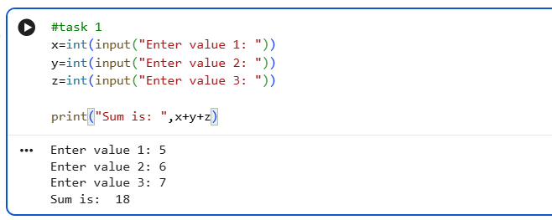
Task 2
Write a program that takes a number and print its square.
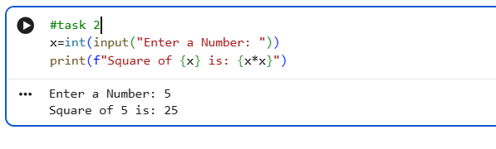
Task 3
Write a program that reads the length of the base and the height of a right angled
triangle and prints the area. Every number is given on a separate line.
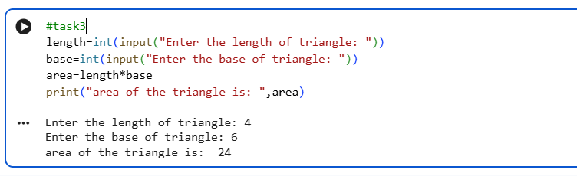

Task 4
Write a program to check whether an integer is positive, negative, or zero
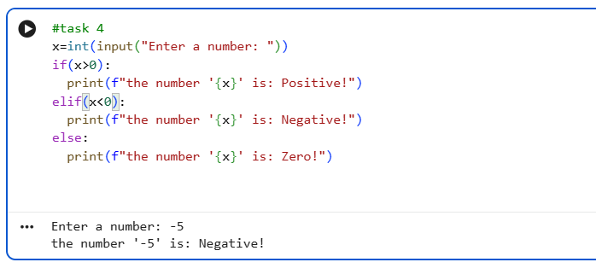
Task 5
Write a program to input marks of five subjects Physics, Chemistry, Biology,
Mathematics, and Computer. Calculate percentage and grade according to
following: Percentage >= 90% : Grade A
Percentage >= 80% : Grade B
Percentage >= 70% : Grade C
Percentage >= 60% : Grade D
Percentage >= 40% : Grade E
Percentage < 40% : Grade F
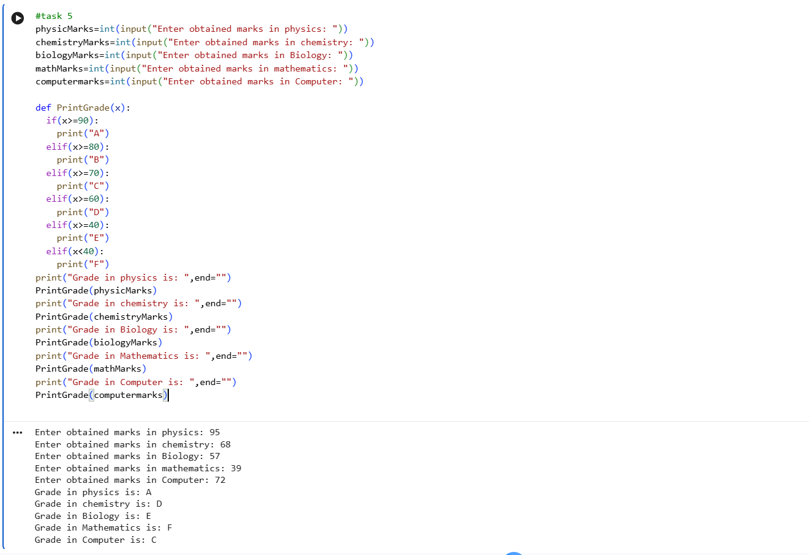

Task 6
Write a Python program to get a single string from two given strings, separated by
a space and swap the first two characters of each string Sample String :
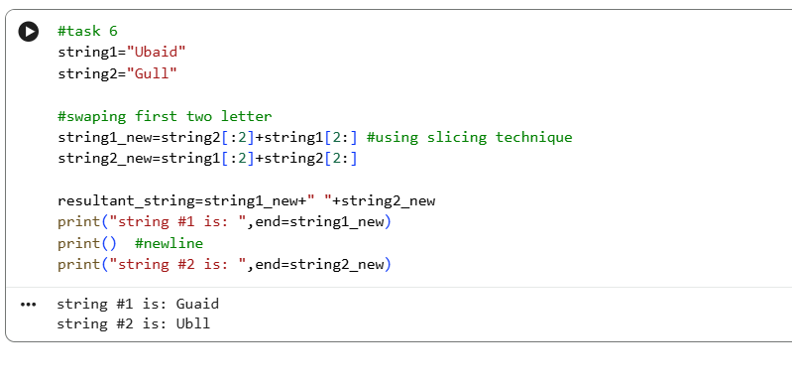
Task 7
Write a Python program that prints all the numbers from 0 to 6 except 3 and 6.
Note : Use 'continue' statement.
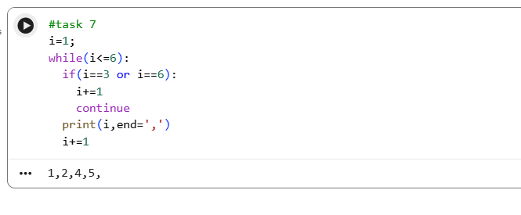
Task 8
Write a Python program to construct the following pattern using for loop.
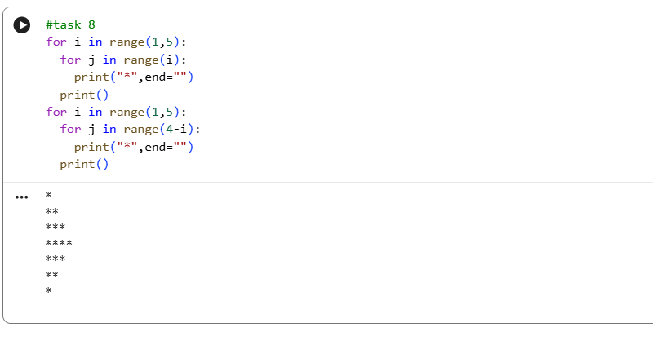
Task 9
Write a Python program that iterates the integers from 1 to 50. For multiples
of three print "Fizz" instead of the number and for multiples of five print "Buzz".
For numbers that are multiples of three and five, print "FizzBuzz".
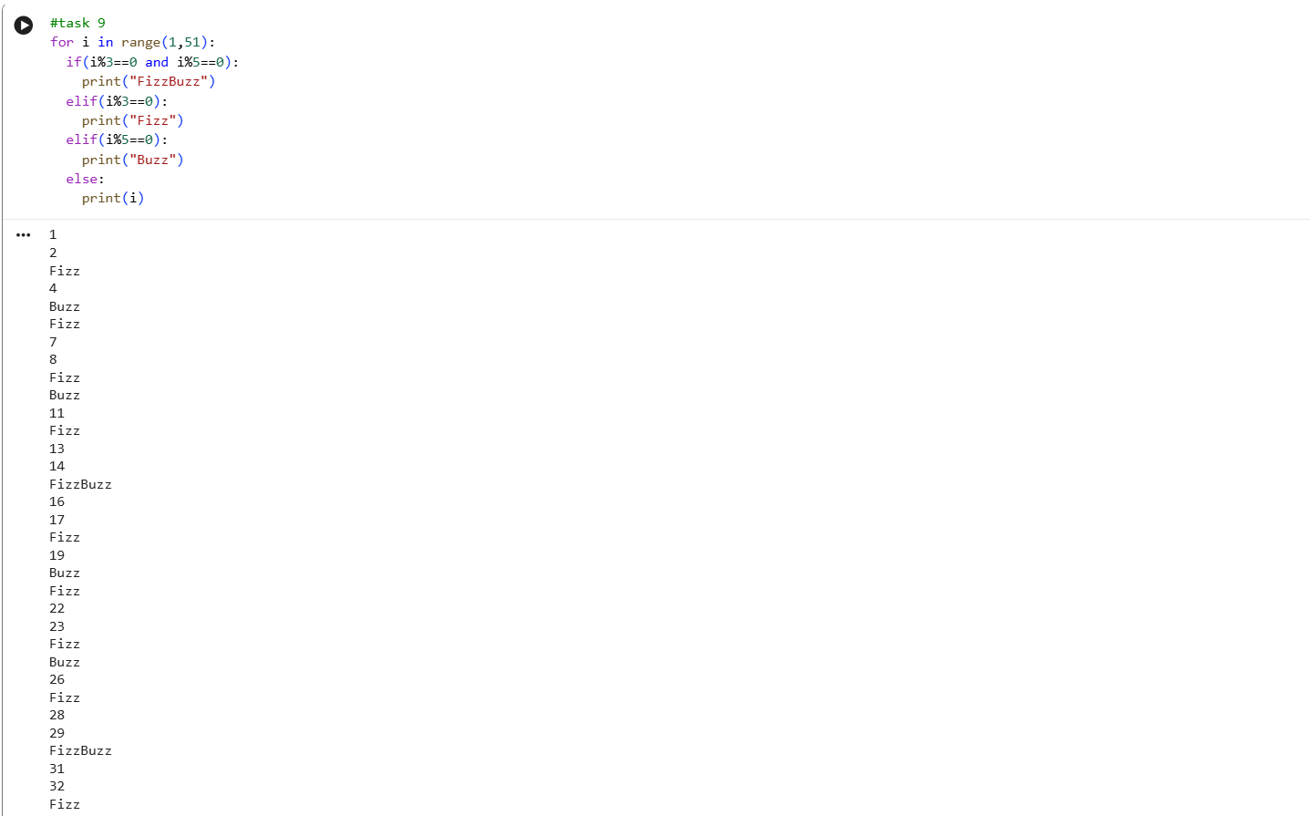

Task 10
Write a Python program that accepts a string and calculates the number of digits
and letters.
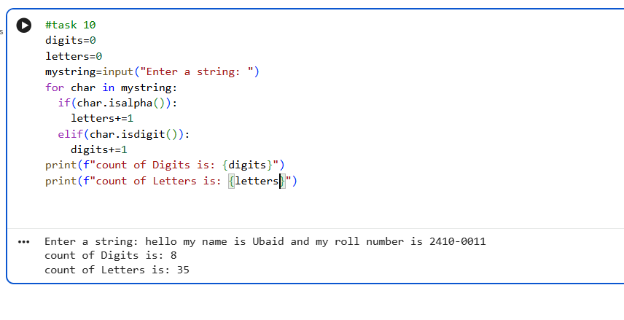
Task 11
Write a Python program to check the validity of passwords input by users.
Validation:
• At least 1 letter between [a-z] and 1 letter between [A-Z].
• At least 1 number between [0-9].
• At least 1 character from [$#@].
• Minimum length 6 characters.
• Maximum length 16 characters.
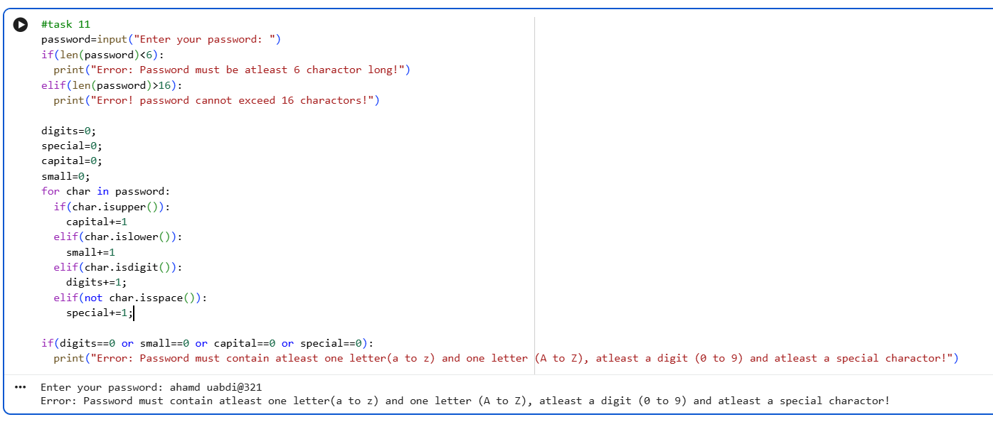
Task 12
12. Write a Python program that removes and prints every third number from a list of
numbers until the list is empty.
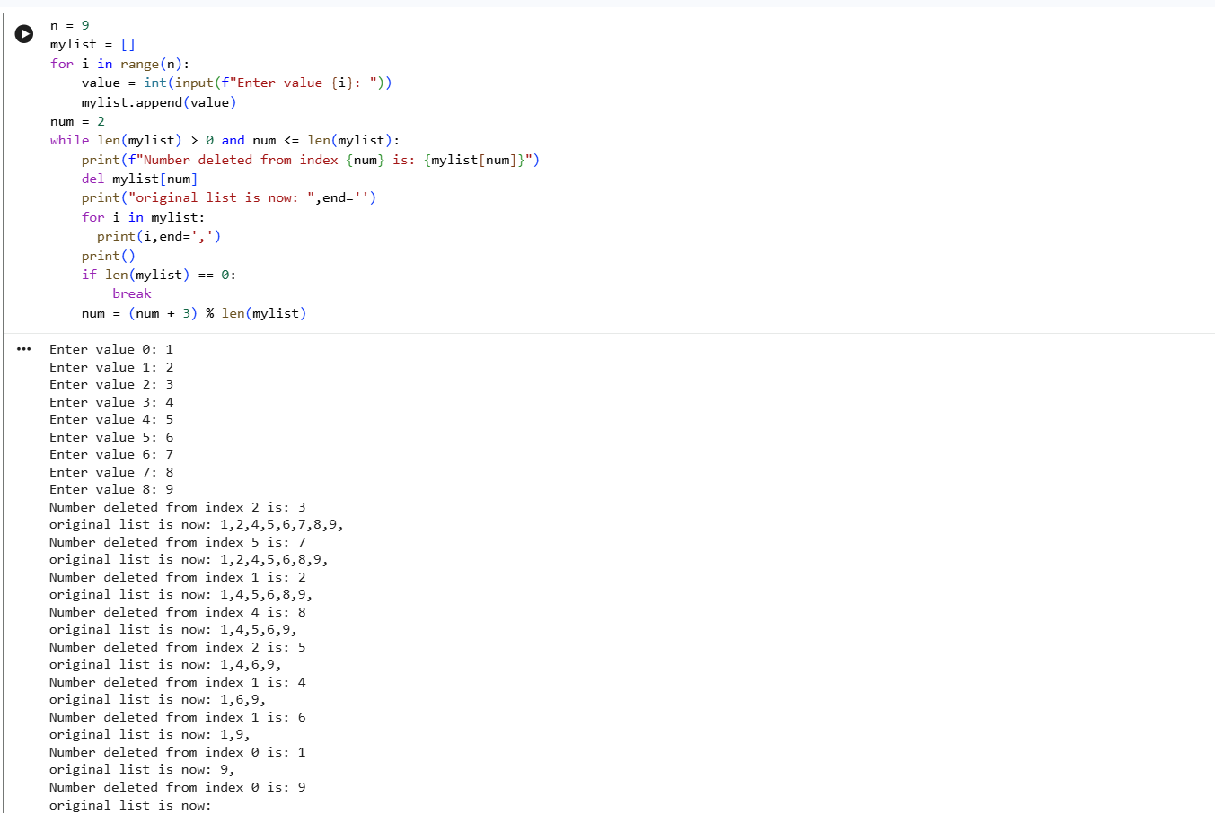
End,,,

